Lae alla ver. 7.0 virtualbox <https://www.virtualbox.org/wiki/Download_Old_Builds_7_0>

Võta [vagrantfile](https://drive.google.com/file/d/1huBrUQXmL9vgqbH_uvtWM2-UFzTE4ptt/view?usp=sharing)

pane vagrant file c:/vagrant kausta

cd c:/vagrant

vagrant up

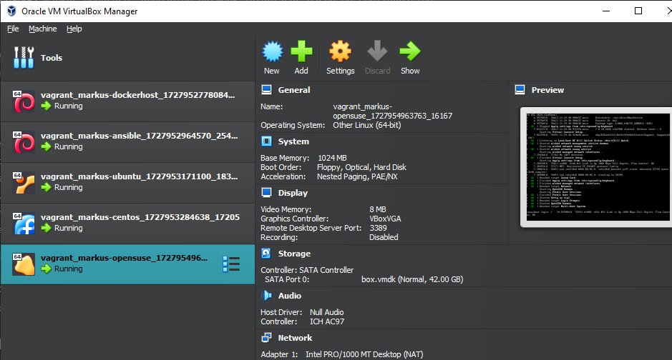

vagrant ssh MASINA-NIMI

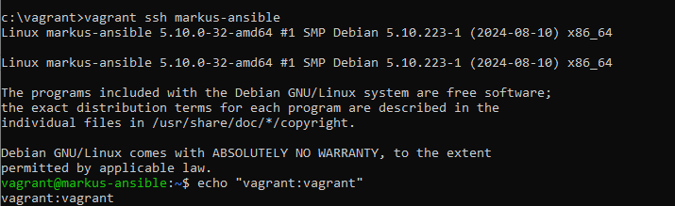

kui tahad parooli vahetada:  
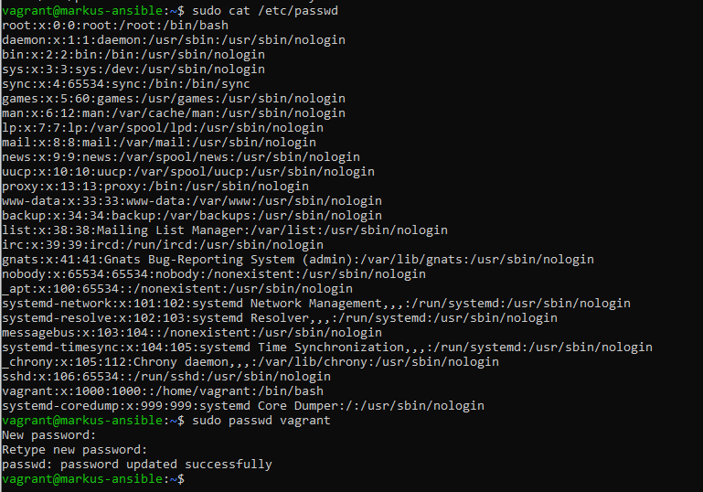

**Mine ansible vmi**

sudo mkdir /ansible

sudo nano masinad.ini

[linux_servers]

markus-dockerhost ansible_host=10.10.10.130 ansible_user=vagrant ansible_ssh_private_key_file=/vagrant/.vagrant/machine>markus-ubuntu ansible_host=10.10.10.132 ansible_user=vagrant ansible_ssh_private_key_file=/vagrant/.vagrant/machines/ma>markus-ansible ansible_host=10.10.10.131 ansible_user=vagrant ansible_ssh_private_key_file=/vagrant/.vagrant/machines/m>markus-centos ansible_host=10.10.10.133 ansible_user=vagrant ansible_ssh_private_key_file=/vagrant/.vagrant/machines/ma>markus-opensuse ansible_host=10.10.10.134 ansible_user=vagrant ansible_ssh_private_key_file=/vagrant/.vagrant/machines/>

[ubuntu]

markus-ubuntu ansible_host=10.10.10.132

[centos]

markus-centos ansible_host=10.10.10.133

[opensuse]

markus-opensuse ansible_host=10.10.10.134

sudo nano masinad2.yml

---

- name: Kontrolli, kas kõik masinad on püsti ja vastavad

hosts: LinuxiServerid

tasks:

- name: Ping masinad

ansible.builtin.ping:

ansible-playbook -i hosts.ini ping_playbook.yml

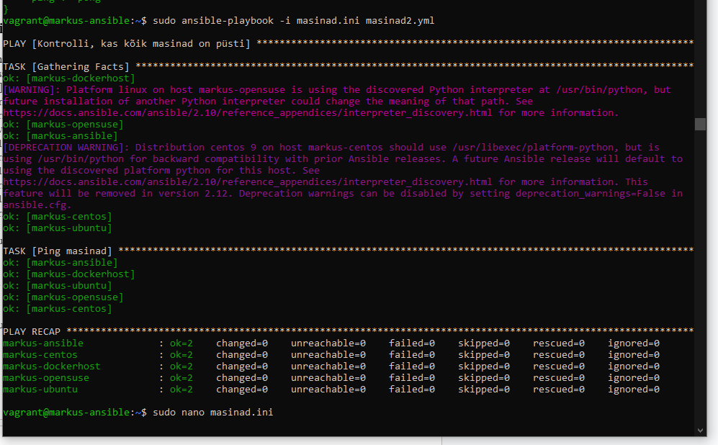

sudo nano masinad3.yml

---

- name: Kontrolli, kas paigaldatud tarkvara on olemas

hosts: linux_servers

tasks:

- name: Kontrolli, kas tarkvara on paigaldatud

ansible.builtin.yum:

name: "{{ item }}"

state: present

loop:

- fish

- tmux

- mc

- wget

- tree

- git

- docker.io

- ansible

- sshpass

- yamllint

- ansible-lint

when: ansible_os_family == "RedHat"

- name: Kontrolli, kas tarkvara on paigaldatud

ansible.builtin.apt:

name: "{{ item }}"

state: present

loop:

- fish

- tmux

- mc

- wget

- tree

- git

- ansible

- sshpass

- yamllint

- ansible-lint

when: ansible_os_family == "Debian"

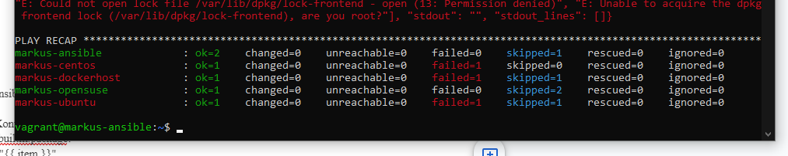

## AWX

sudo install -m 0755 -d /etc/apt/keyrings

sudo curl -fsSL https://download.docker.com/linux/ubuntu/gpg -o /etc/apt/keyrings/docker.asc

sudo chmod a+r /etc/apt/keyrings/docker.asc

echo \

"deb [arch=$(dpkg --print-architecture) signed-by=/etc/apt/keyrings/docker.asc] https://download.docker.com/linux/ubuntu \

$(. /etc/os-release && echo "$VERSION_CODENAME") stable" | \

sudo tee /etc/apt/sources.list.d/docker.list > /dev/null

sudo apt update

sudo apt install docker-ce docker-ce-cli containerd.io docker-buildx-plugin docker-compose-plugin -y

sudo usermod -aG docker $USER

newgrp docker

docker --version

systemctl status docker

sudo apt update && sudo apt upgrade -y

sudo reboot

curl -LO https://storage.googleapis.com/minikube/releases/latest/minikube-linux-amd64

sudo install minikube-linux-amd64 /usr/local/bin/minikube

minikube version

curl -LO "https://dl.k8s.io/release/$(curl -L -s https://dl.k8s.io/release/stable.txt)/bin/linux/amd64/kubectl"

chmod +x kubectl

sudo mv kubectl /usr/local/bin/

kubectl version -o yaml

minikube start --driver=docker

minikube addons enable metrics-server

minikube addons enable ingress

minikube addons enable dashboard

